**Web Programming Languages**

**Final Project Report – Pizza Delivery web application**

**Team:**

**Maitri Naresh Sanghavi MXS180131**

**Rakesh Reddy RRR190000**

**Sai Teja Peddi SXP180107**

**Introduction:**

Joey’s Pizza is a pizza delivery website which allows a registered user to order pizza and various other items available on the website that the Pizza shop has to offer.

**Technologies / Frameworks used:**

* Frontend: Bootstrap, HTML5, CSS
* Backend: Node JS , JS, JQuery
* Database: Mongo DB

**Functions available to the user:**

1. Customer:

* The customer can check out the menu, order items from the menu.
* All the items in the menu will be visible to the customer.
* The customer can search and filter the items they would like to view and order.
* They can edit their orders by going to their cart and remove the items they would not want to order.
* Once the customer is ready to place the final order, they can check out the items in their cart.
* After the customer checks out their order, **they can check their Order details in the Previous Orders.**

2. Admin:

* Apart from the functionalities that the normal customer has, the admin has a few additional services.
* The admin can edit the item details in the Menu.
* The admin can add new items in the Menu.
* The admin can also delete the items that are visible in the menu, although this is just a soft delete. Once the item is soft deleted from the menu it will not be visible to the user as well as admin in the Menu page.

3. Cart

* Items can be added to the cart.
* Items can be removed from the cart.
* Once all the Items are added, we can check out and place the order upon which

the final price will be visible to the user.

4. Menu

* Many items are available depending on the category.
* User can view items based on categories like drinks, pizza, pasta and burgers.
* Same menu is displayed for both admin and normal user.
* Items on the menu can be soft deleted by the admin such that it won’t be available to the normal user.

5. Search and filter

* Items can be searched.
* Items can be filtered.
* Items can be searched and filtered simultaneously.

6. Login and registration

* Users need to register to login.
* When users try to register, the Email ID is matched from the DB and if the Email Id is already present on file then they are not allowed to register.
* All the passwords are hashed before storing in the DB.

**Assumptions:**

* The user can view the menu even if he is not registered or logged in to the website.
* To place the order the user has to login, otherwise they cannot place the order.
* The quantity of items that a user can order is limited to 10.
* When editing the order details in the cart, if the user does not want any toppings, he must select None as the option otherwise the order won’t be edited.
* Once the order is checked out the user cannot cancel their orders.
* The user can place orders at any time and from anywhere.

**Functionalities:**

* When a new user visits the website, they can register to the website. Here if the user is already registered, an error will be thrown.
* A validation will be performed to check if the password is matched when registering. Also, if a field is missing the user will not be able to register.
* The password will be hashed and stored in the hashed version in the database.
* User will be able to login using the username and password.
* The user can see all the available products in the ‘Menu’ tab.
* The user can search and filter for an item he desires to see in the ‘Menu’ tab.
* When trying to place order for items which can have various topping the toppings can also be selected along with the quantity.
* Once the order is selected, the item will be added to the Cart.
* In the cart the user can edit and remove the item/s.
* On checking out, the order will be placed and moved from Cart to Previous Orders where the order history can be checked.
* Also, if the user adds the items to the Cart and logs out without placing the order, the items will be found in their cart when they login again to the website.
* The Admin has additional functionalities.
* All the items will be listed for the Admin in the Menu page.
* The Admin can add new items to the Menu.
* The Admin can update the item details in the Menu.
* The Admin can also (soft) delete the items from the Menu.

**Database Structure:**

1. **Accounts**

{

"_id" : ObjectId("5eaa0523143ab13f089b3c3c"),

"isAdmin" : true,

"username" : "Maitri",

"salt" : "e5cae674408bb7ac447c84bf1332f17ee70a17c11f7600936f3f6d659d5b015d", "hash":"",

"__v" : 0

}

Above is the example structure of the accounts relation. **Id** here defines the user id, **isAdmin** is a Boolean field which determines if the user is admin or not. It’s true for admin and false for normal users. **Username** is the name of the user, **Hash** is the hashed version of the password stored in the DB.

1. **Menu**

{

"_id" : ObjectId("5eaa028eb55c67d309515fe5"),

"title" : "Margarita Pizza",

"image" : "pizza-6.jpg",

"description" : "Margarita Pizza is a savory dish of Italian origin, consisting of a usually

round, flattened base",

"price" : "$10.00",

"category" : "pizza",

"activeflag" : "0"

}

Above is the example of an object in the menu. **Id** is the unique id for every item. **Title** is the name of the item. **Image** is the name of the image to browse and add to the item. **Description** is data about the item. **Price** is the cost of the item. **Category** is the set the item belongs to, like pizza, pasta burger or drink. **Activeflag** is either 1 or 0 depending on if the item is soft deleted or displayed on the menu.

1. **Orders**

{

"_id" : ObjectId("5eb09f7eb55c67d309523ec6"),

"user_id" : "5eb09f287c4e5950cc900d60",

"__v" : 0,

"dateandtime" : [

ISODate("2020-05-04T23:04:30.738Z"),

ISODate("2020-05-04T23:05:12.725Z"),

ISODate("2020-05-04T23:05:34.035Z")

],

"items" : [

{

"toppings" : [

"Onions",

"Green Olives"

],

"_id" : ObjectId("5eb09fa87c4e5950cc900d66"),

"name" : "Caucasian Pizza",

"crust" : "HAND TOSSED",

"size" : "MEDIUM 12",

"quantity" : 3,

"baseprice" : 8.5,

"totalprice" : 25.5

},

{

"toppings" : [],

"_id" : ObjectId("5eb09fbe7c4e5950cc900d69"),

"name" : "Sweet lime juice",

"crust" : "NA",

"size" : "NA",

"quantity" : 3,

"baseprice" : 3,

"totalprice" : 9

}

],

"finalPrice" : 34.5

}

Above displayed is an object of the order placed. **Id** is the id of the order being placed. **User_id** is the id of the user placing the order. **Dateandtime** contains the date and time when various items were added to the cart. **Items** is the array of the objects in the current order. **Toppings** is the list of all toppings added for a pizza, this field doesn’t make sense for a pasta or a drink. **Id** here is the object ID being added, **Name** is the name of the item, **crust and size** are the features of a pizza with various categorical values. **Quantity** is the number of the specific item required, **Base Price** is the price of pizza without all toppings, **Total Price** is the price total prize of the current item after adding the price of all toppings. **Final price** is the price of the total order.

1. **Cart**

{

"_id" : ObjectId("5eb0a790b55c67d309524d13"),

"user_id" : "5eb0a50a62ebc55344a62fac",

"__v" : 0,

"dateandtime" : [

ISODate("2020-05-04T23:38:55.977Z"),

ISODate("2020-05-04T23:39:03.948Z")

],

"items" : [

{

"toppings" : [],

"_id" : ObjectId("5eb0a790304613a9e8461a5a"),

"name" : "Grapefruit juice",

"crust" : "NA",

"size" : "NA",

"quantity" : 3,

"baseprice" : 3,

"totalprice" : 9

},

{

"toppings" : [],

"_id" : ObjectId("5eb0a797304613a9e8461a5d"),

"name" : "Chicken Parmigiana",

"crust" : "NA",

"size" : "NA",

"quantity" : 5,

"baseprice" : 8,

"totalprice" : 40

}

],

"finalPrice" : 49

}

Above is the structure of the cart. Everything here is same as that of the order, but once the order is placed all details here are removed.

**Screenshots**

1. **Home Page**

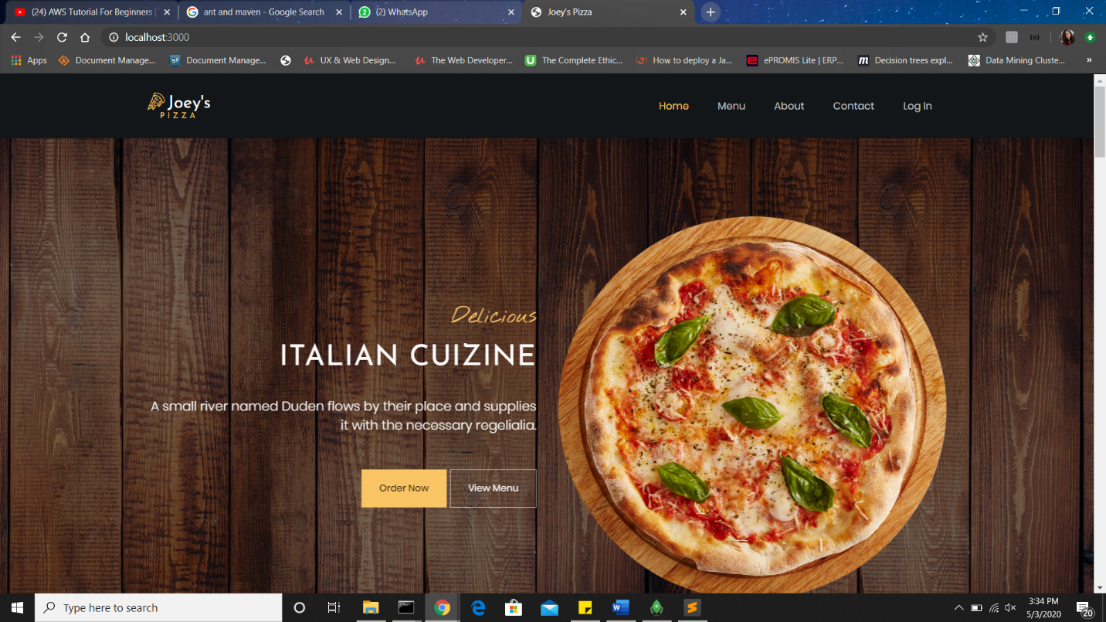

1. **Login Page**

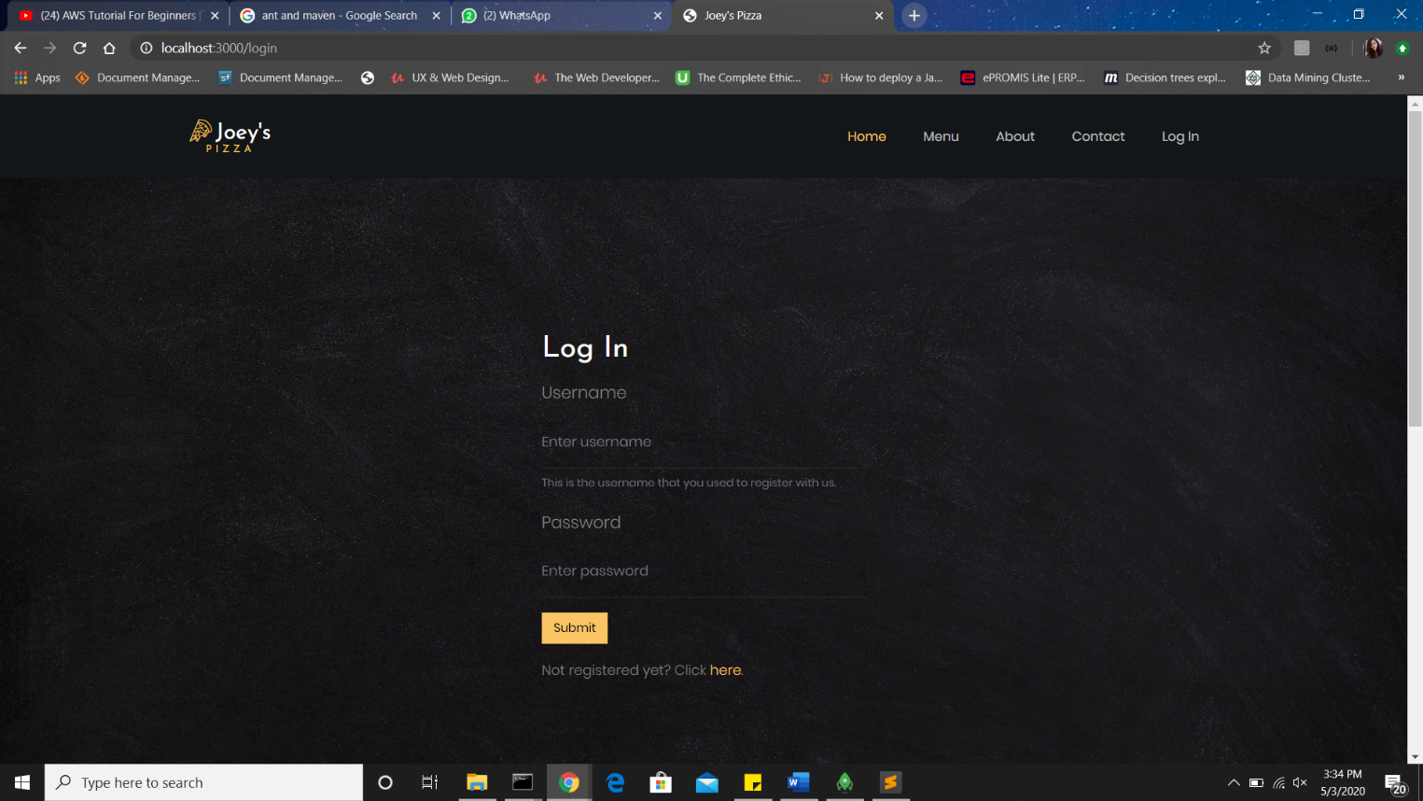

1. **Registration Page**

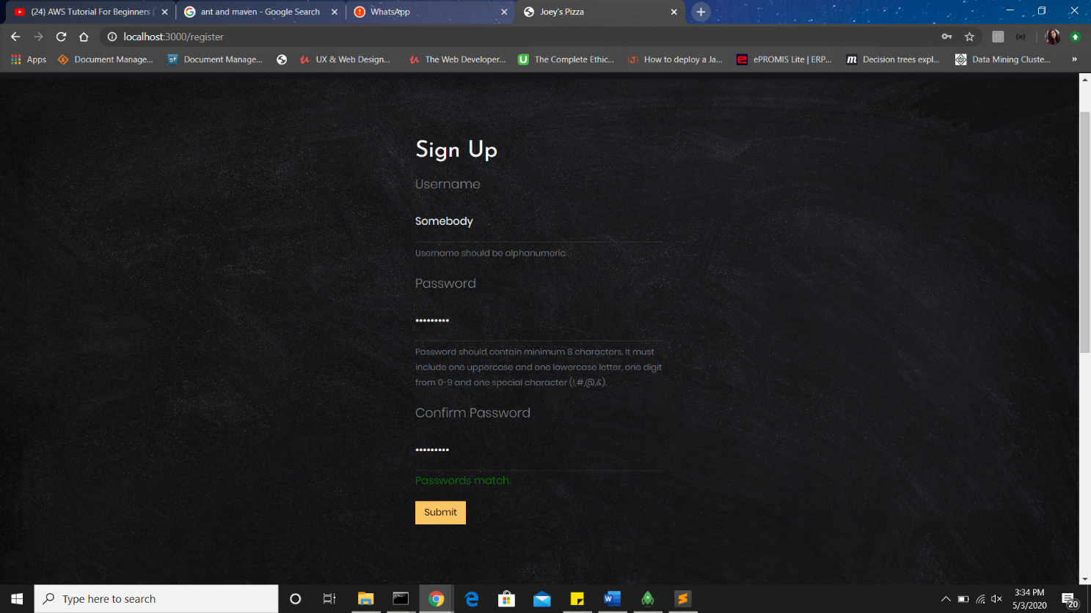

1. **Menu Page**

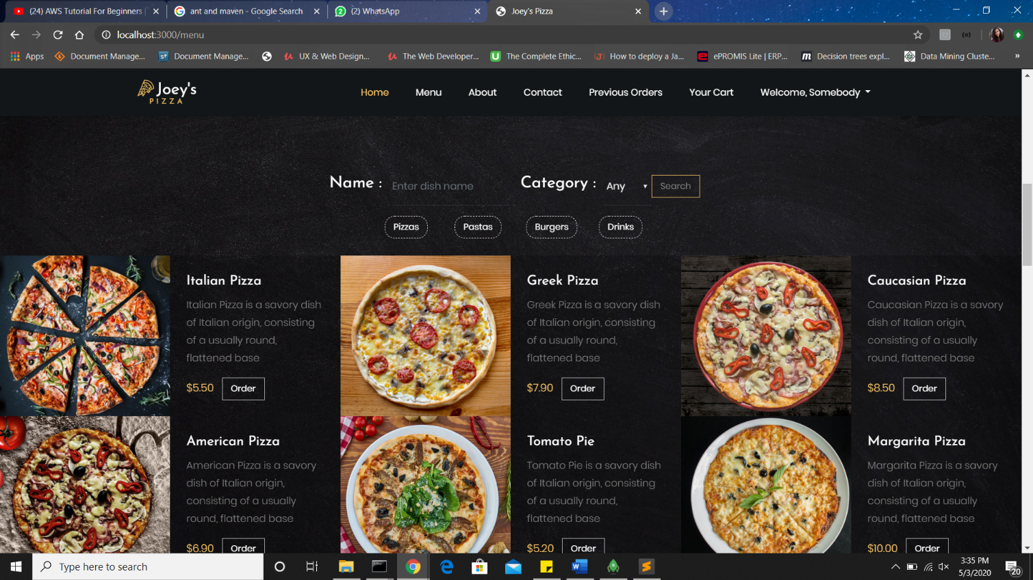

**5. Cart Page**

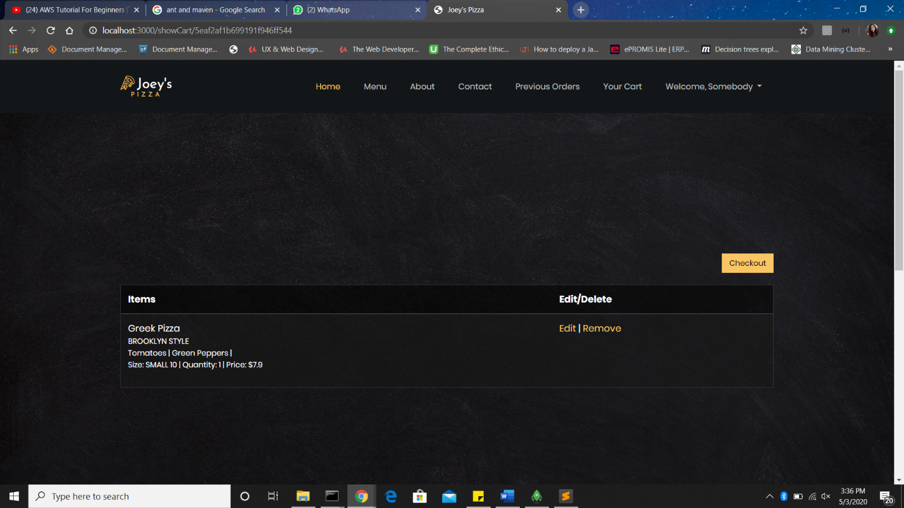

**6. Previous Orders Page**

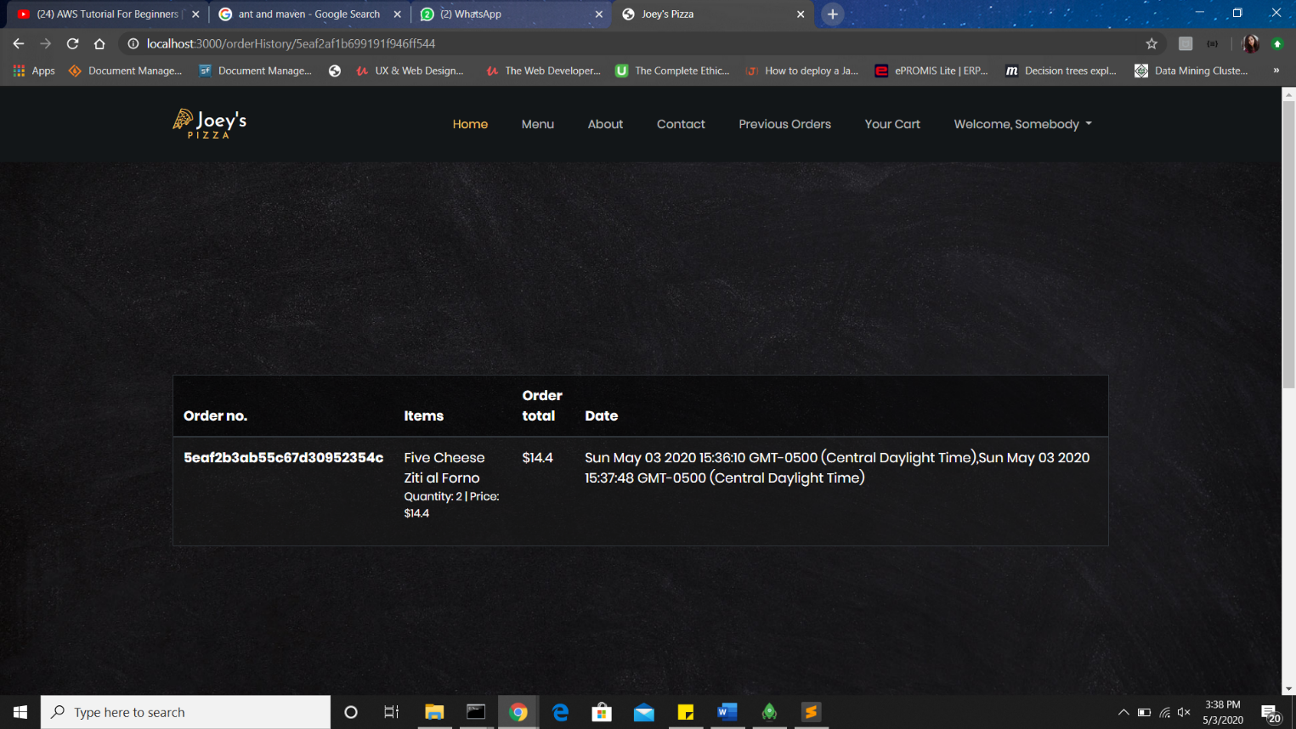

**7. Admin’s Menu Page**

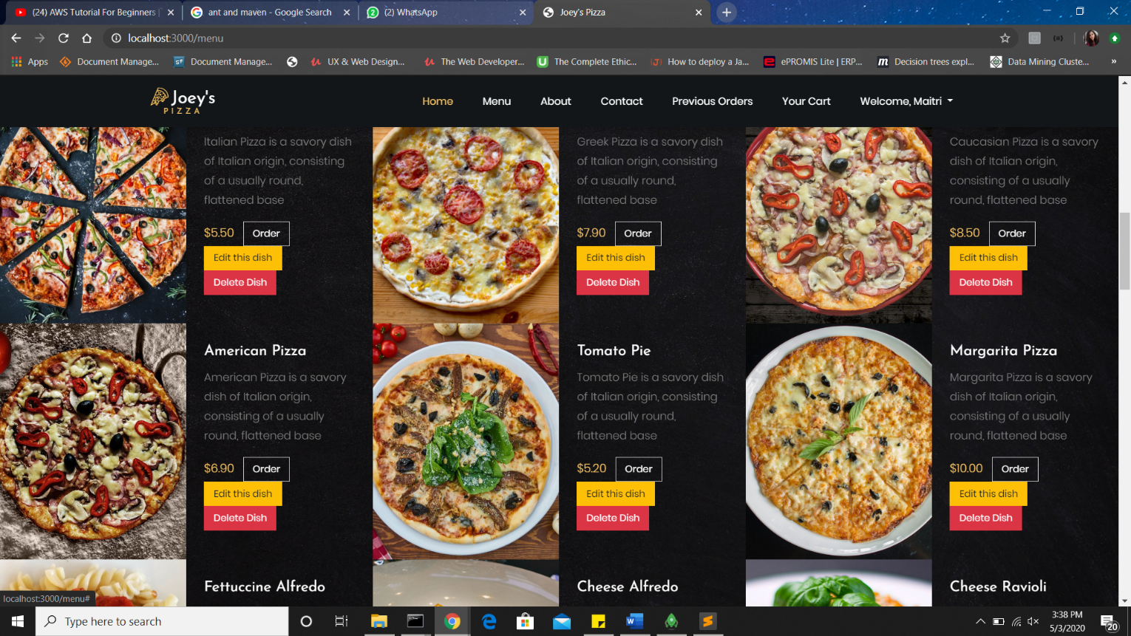

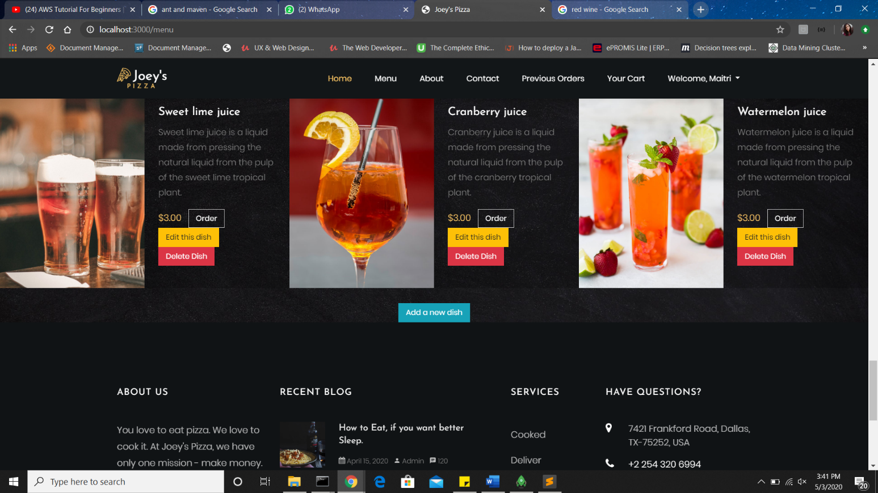

1. **Admin’s Add New Item Page**

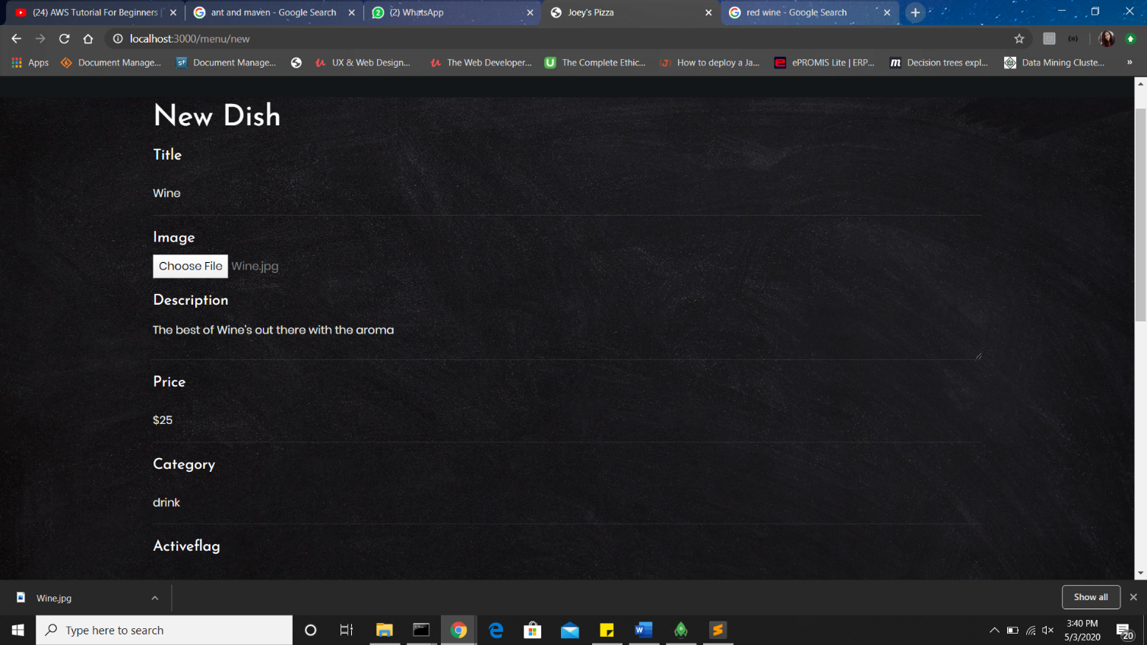

1. **Admin’s Edit Items Page**

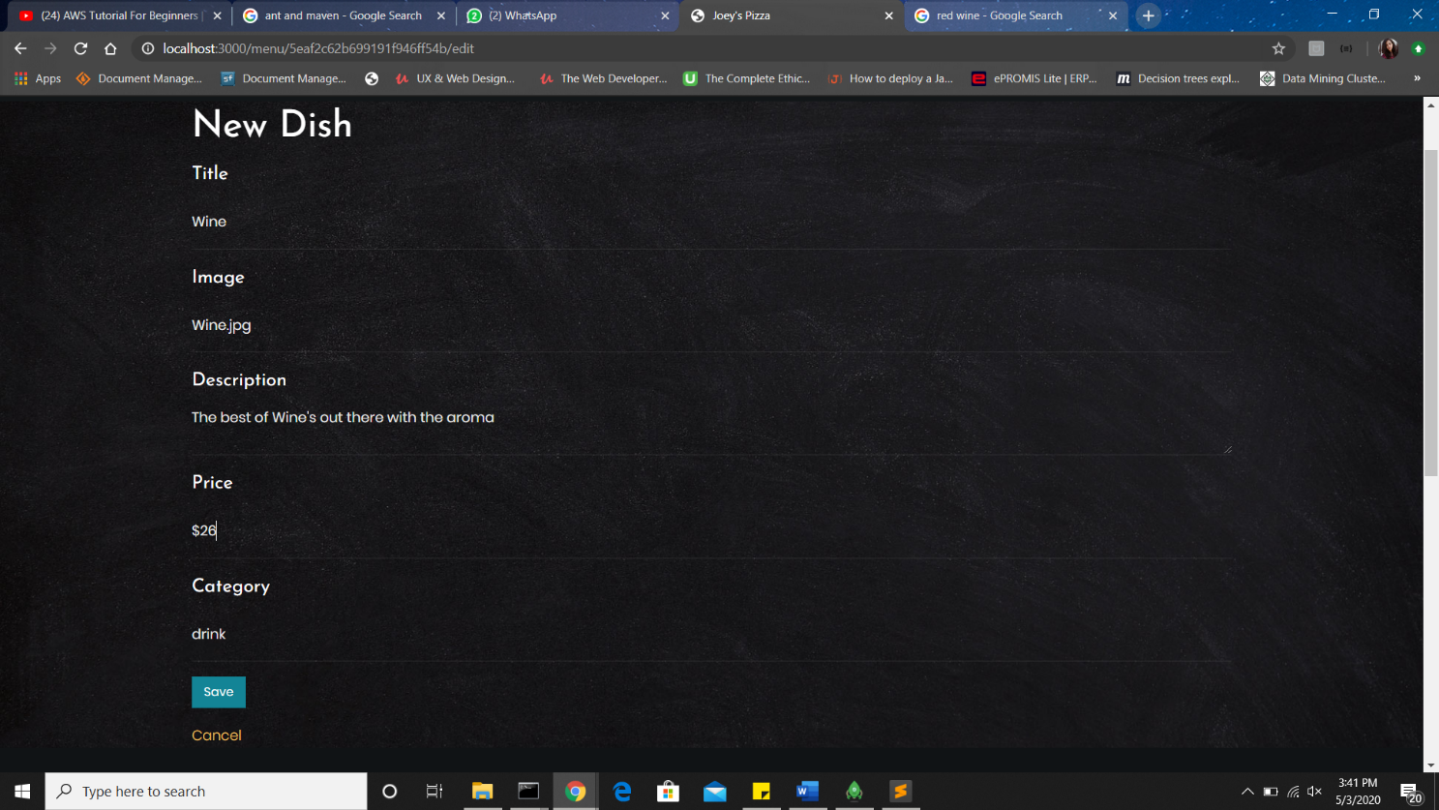

**Work division**

All the team members contributed equally and pushed each other to bring out the best in themselves. The specifics of the work divided are listed as below:

* Maitri Naresh Sanghavi

She has worked on finding the template, designing of the database, cart page, previous orders page, admin add to cart, edit cart, soft delete , Order Checkout from the Cart, Show history of User’s Orders.

* Sai Teja Peddi

He has worked on creating the home page, about page, contact page and the menu page, searching and filtering, displaying all items , adding items to cart, update items in the Cart.

* Rakesh Reddy

He has worked on creating the login page, register page, username validation, form validation, password validation, password hashing, paging functionality in the Menu Page, delete items in the Cart.

**Summary**

The task of developing a pizza delivery application was challenging but was a great learning experience. It made us brainstorm a lot about the various functionalities in our application, we learnt a lot from each other and put into practice a lot of the things that we learnt in the course. We believe it was a fitting way to summarize all our learnings and we are proud to have successfully completed the project with all the functionalities that were expected of us.

We would like to thank you for teaching us this course and taking the time to review our project.